# **Experiment 4:** Create a simple cloud software application for Hospital information system for SIMATS Hospital using any Cloud Service Provider to demonstrate SaaS with fields of patient name, age, address, phone, email, Attender name, attender phone, doctor name, diseases, etc.

Step 1: Create a Application Form For Patient Details

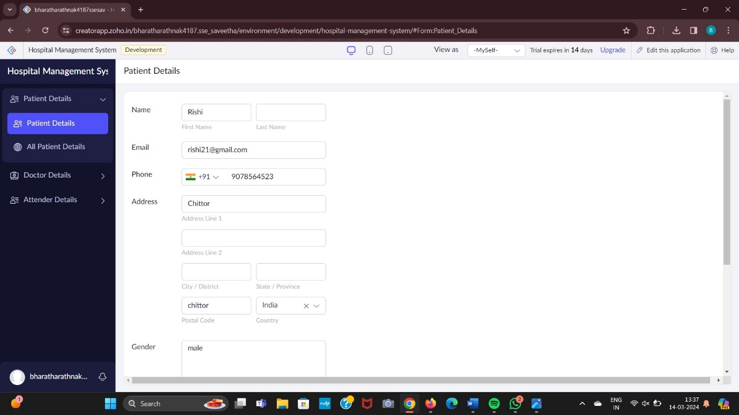

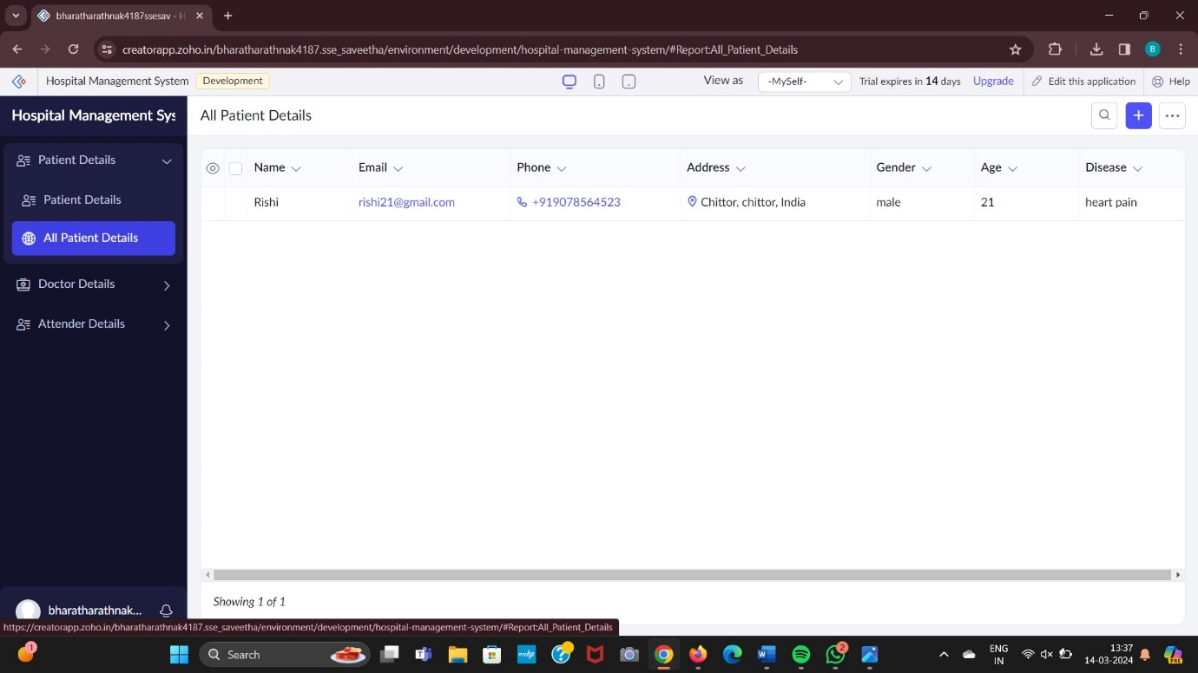

Step 2: Creating a Application Form For Doctor Details

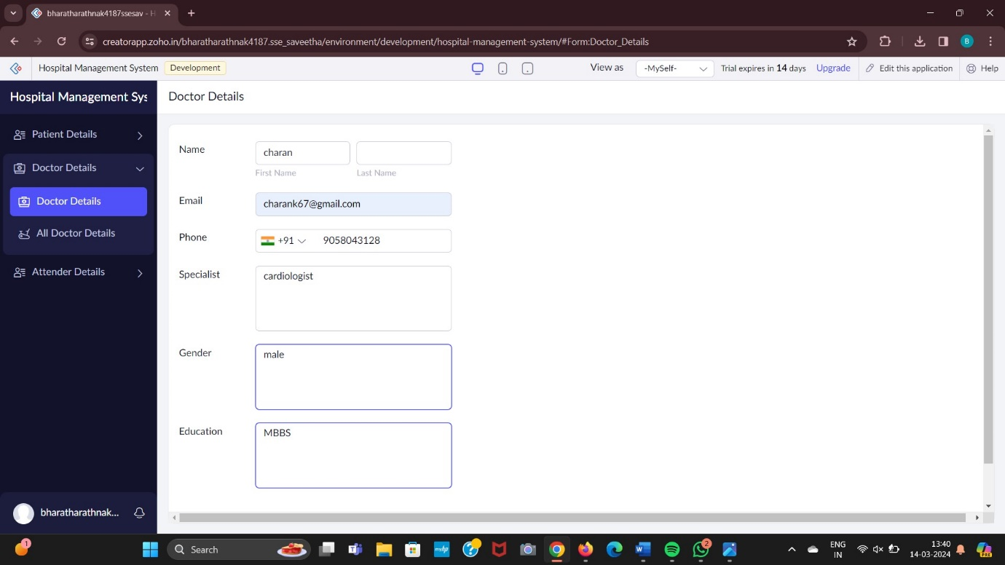

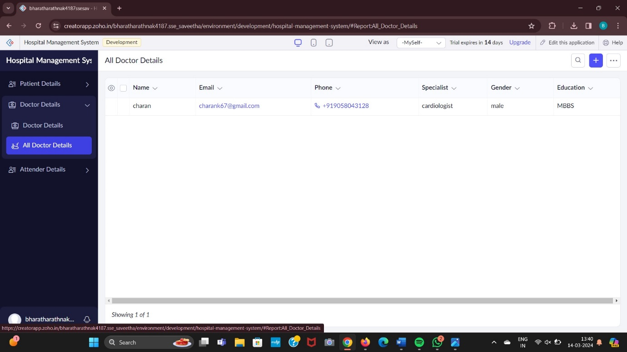

Step 3: Creating a Application Form For Attender Details. 